Worksheet 3.4

Fossils
Student: Class:

Archaeopteryx

1. The photo below shows the 150-million-year-old fossilised remains of an Archaeopteryx.

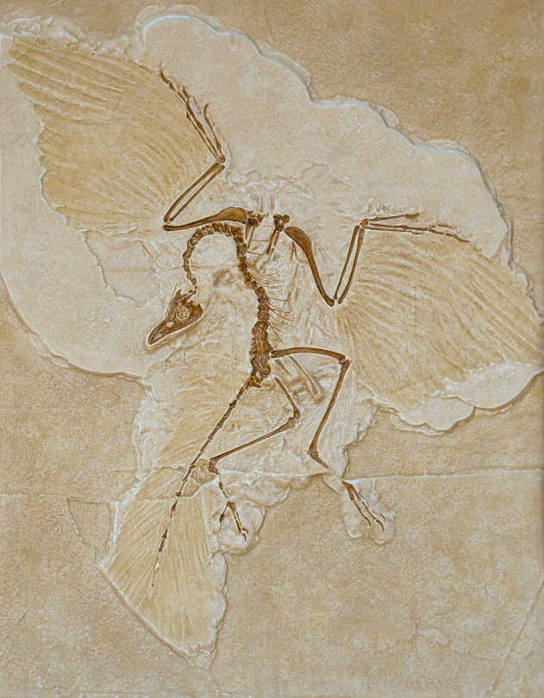

(a) Identify the features that survived the fossilisation process.

(b) Explain why these features survived whereas others did not.

(c) Explain the scientific importance of this fossil.

Worksheet 3.4

Page 2

Ancient leaves
2. The photo below shows the remains of ancient leaves that have been fossilised.

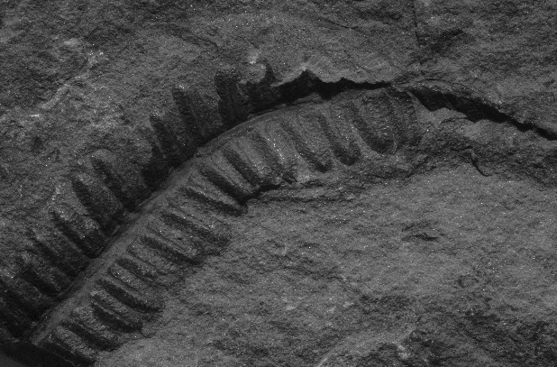
(a) Classify this type of fossil.

(b) Explain how this fossilisation process has occurred.

Insects
3. The photo below shows a fossilised insect.
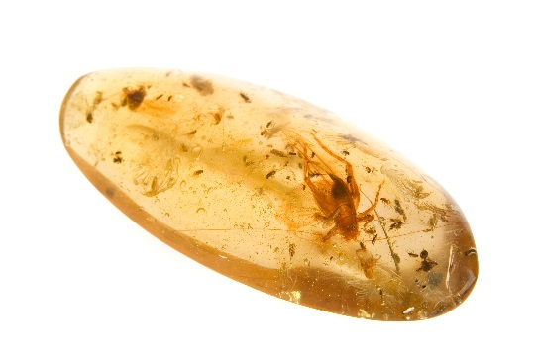

(a) Classify this type of fossil.

(b) Describe how the body of this insect was preserved.

